LOK JAGRUTI KENDRA UNIVERSITY
M.Sc. Cybersecurity Semester III
Class Test
Subject Code:340110314 Date: 26/10/2026
Subject Name: Cyber Security Fundamentals & Network Security
Duration: 01:00 Hour Total Marks: 10

NOTE: All the Practical’s are compulsory
- Mention Set number & Enrollment number in the answer sheet (If not written or wrong set number is written then answer sheet will not be evaluated and marked zero.)
- Also, only if the answers are correct then and then marks will be given
- Make sure no other documents apart from the necessary documents (which require during exam) for the exam should be open (If open then liable for the UFM)
- For the Viva, if student can’t answer the question, then 0 marks will be given by the invigilator/ viva taker.
- During exam, if student finds doing any copy paste from any document or taking help from the online medium then answer won’t be accepted and will get 0 marks for the whole exam (UFM)
- Students can write down the analysis according to the steps, make sure steps include technical words only (If not then marks will be given accordingly).
- Also Screen Shot should be appropriate as per the steps and important things must be highlighted in the Screenshot with the Timestamps (If not then marks will be given accordingly)
- Most Importantly, screenshots without proper visibility of timestamps will not be considered and the student can be liable to get 0 marks.
- If any students have just mentioned the Steps without appropriate Screenshots, then the question gets 0 marks.
- If the Browser history Screenshot before and after the exam is not there then marks will be deducted accordingly.
- Answer sheet will only be accepted in the google classroom submission (If students fail to submit on time due to any reason, they will get 0 marks)

ANSWER SHEET
Practical: 01

AIM: A college wants to separate its MCA Lab and MSC Lab computers. In Cisco Packet Tracer, create VLAN 10 for MCA Lab and VLAN 20 for MSC Lab, assign at least one PC to each VLAN, configure the switch-to-router trunk and router sub interfaces, and test inter-VLAN connectivity using ping. Submit the relevant configuration or verification screenshots.

Procedure

Step 1: Make Network topology

Open Cisco Packet Tracer and make network topology
Add one Router, and one Switch and add 4 PC’s

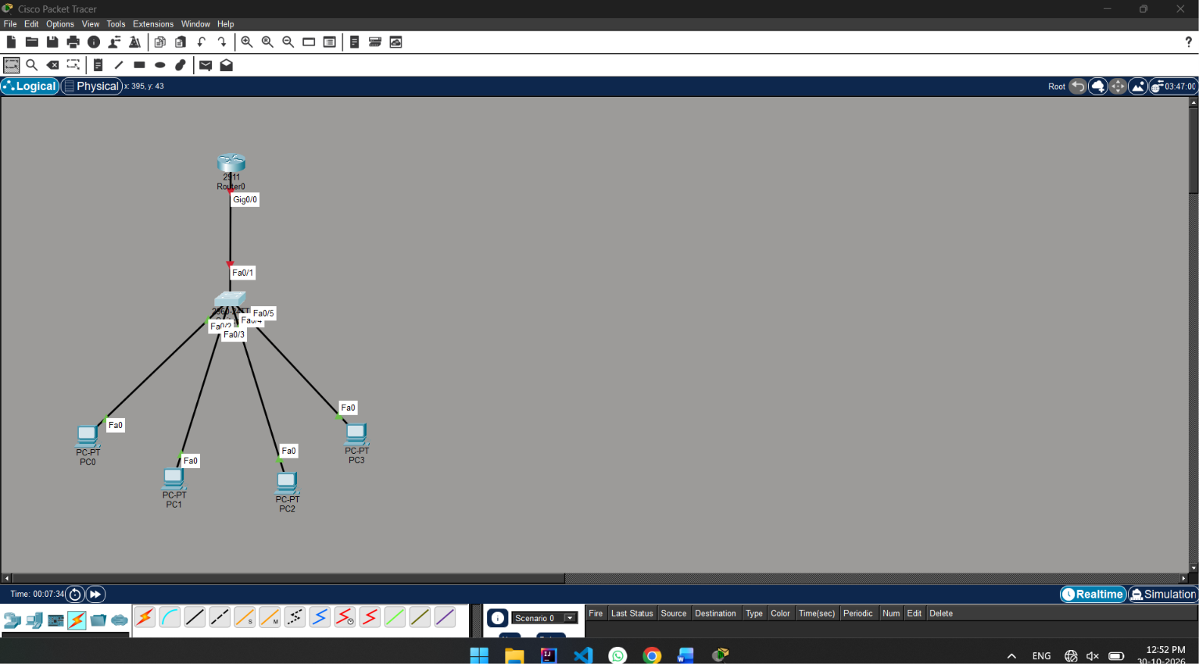
Figure 1: College network topology

POC:
Here in screenshot have network topology, with devices Router, Switch and PC’s
Router Connect with Switch and Switch Connect with 4 PC’s saperatly

Router0 --- Switch0 --- PC0, PC1, PC2, PC

Step 2: Create VLAN MCA & MSC

Dubble click on Switch0 and then click CLI,
Then for creating vlan run command:

enable
configure terminal

vlan 10
name MCA
exit

vlan 20
name MSC
exit

end

show vlan

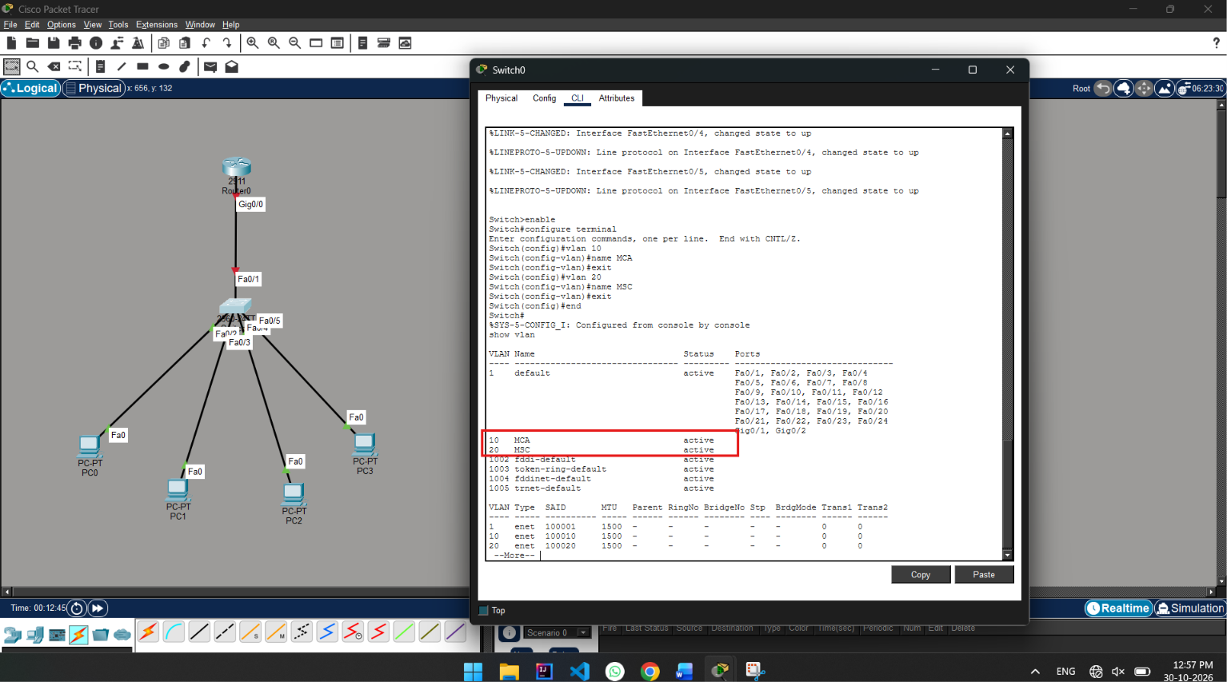

POC:

Here screenshot showing created vlan 10 MCA and vlan 20 MSC.
And, there status is showing Active

Step 3: Switch configuration

In Switch0 CLI run this command:

enable
configure terminal

interface range fastEthernet 0/2-3
switchport mode access
switchport access vlan 10
exit

interface range fastEthernet 0/4-5
switchport mode access
switchport access vlan 20
exit

end

show vlan

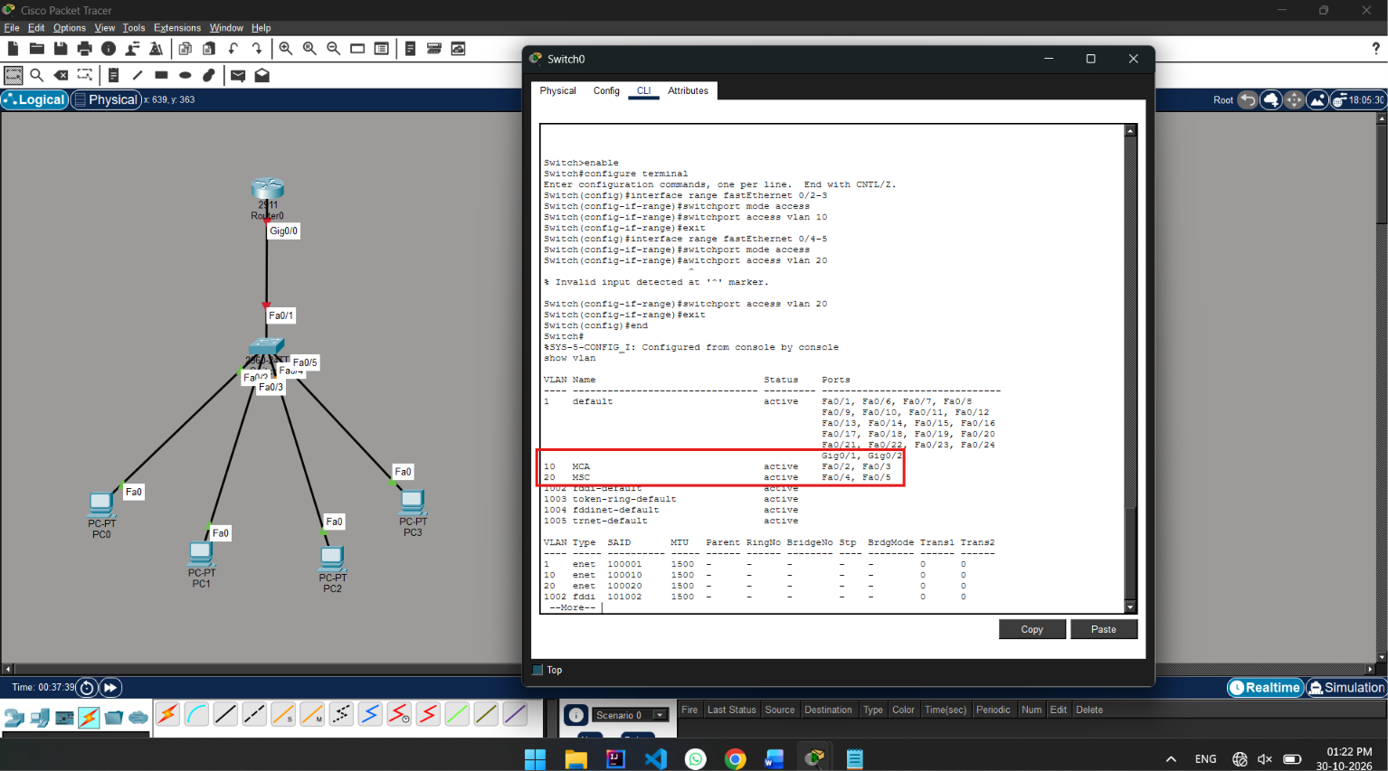

POC:
Screenshot showing switch0 configure vlan for separating pc lan
vlan show command showing that

vlan 10 MCA for PC0 & PC1 (Fa0/2 &Fa0/3)
vlan 20 MSA for PC3 & PC4 (Fa0/4 &Fa0/5)

Step 4: Router Configuration

Router0 CLI run this command:

enable
configure terminal

interface gigabitEthernet 0/0
no shutdown
exit

interface gigabitEthernet 0/0.10
encapsulation dot1Q 10
ip address 192.168.1.1 255.255.255.0
exit

interface gigabitEthernet 0/0.20
encapsulation dot1Q 20
ip address 192.168.2.1 255.255.255.0
exit

end

show ip interface brief

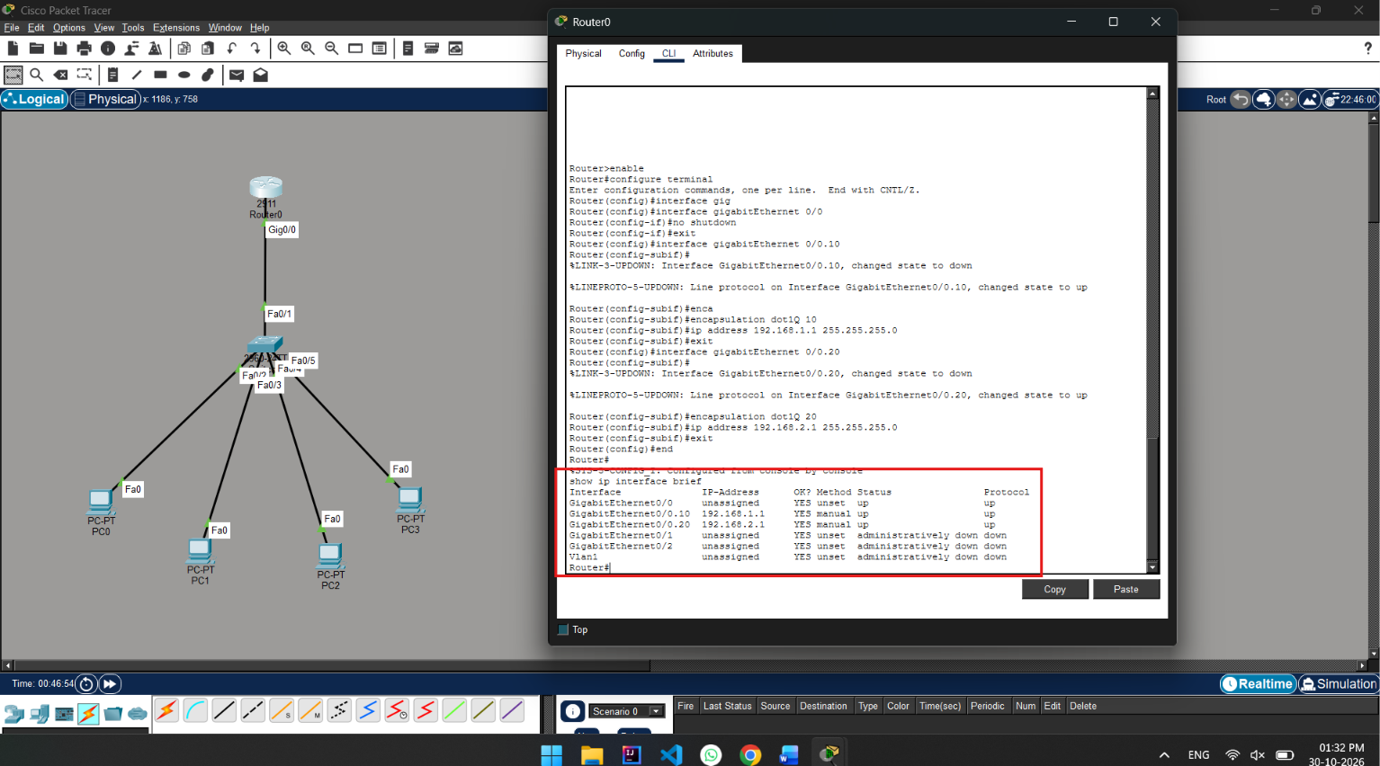

POC:

Here Screenshot sowing last show ip interface brief: both status is up
For both vlan it’s separating ip address is
192.168.1.1 for vlan 10 MCA
192.168.2.1 for vlan 20 MSC

Step 5: Configure Switch Router port trunk

Router0-to-Switch0 connection is:
In Switch0 CLI run this command:

enable
configure terminal

interface fastEthernet 0/1
switchport mode trunk
exit

exit

show interfaces trunk

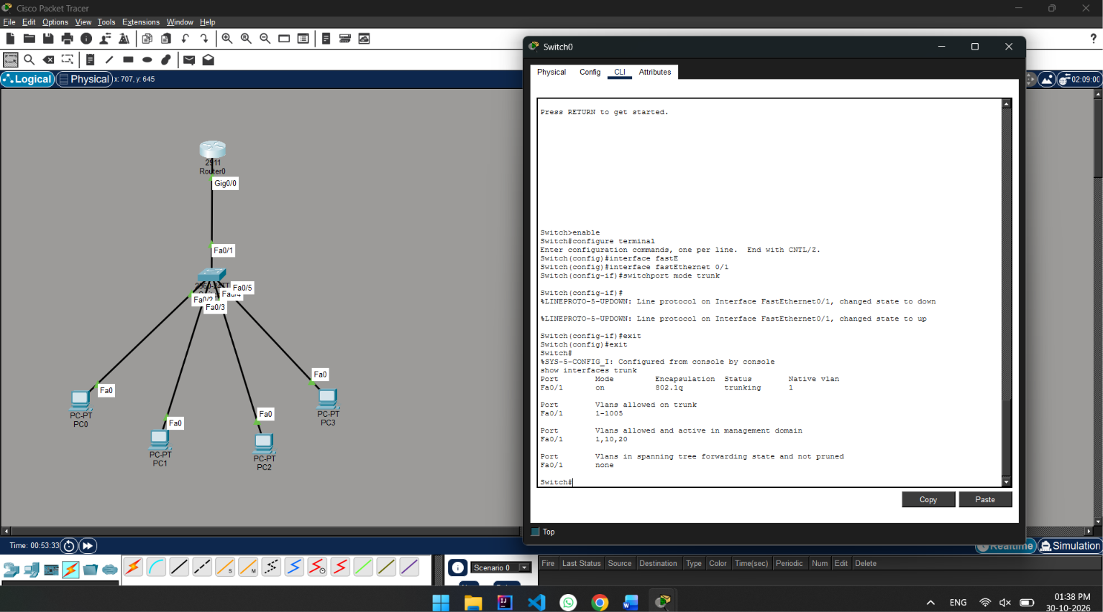

POC:
Here we see trunk command on switch0 and port Fa0/1 mode on and Vlans allowed on trunk

Step 6: Configure PC’s IP addresses

PC0:
Desktop IP Configuration
IP Address: 192.168.1.2
Subnet Mask: 255.255.255.0
Default Gateway: 192.168.1.1

PC1:
Desktop IP Configuration
IP Address: 192.168.1.3
Subnet Mask: 255.255.255.0
Default Gateway: 192.168.1.1

PC2:
Desktop IP Configuration
IP Address: 192.168.2.2
Subnet Mask: 255.255.255.0
Default Gateway: 192.168.2.1

PC3:
Desktop IP Configuration
IP Address: 192.168.2.3
Subnet Mask: 255.255.255.0
Default Gateway: 192.168.2.1
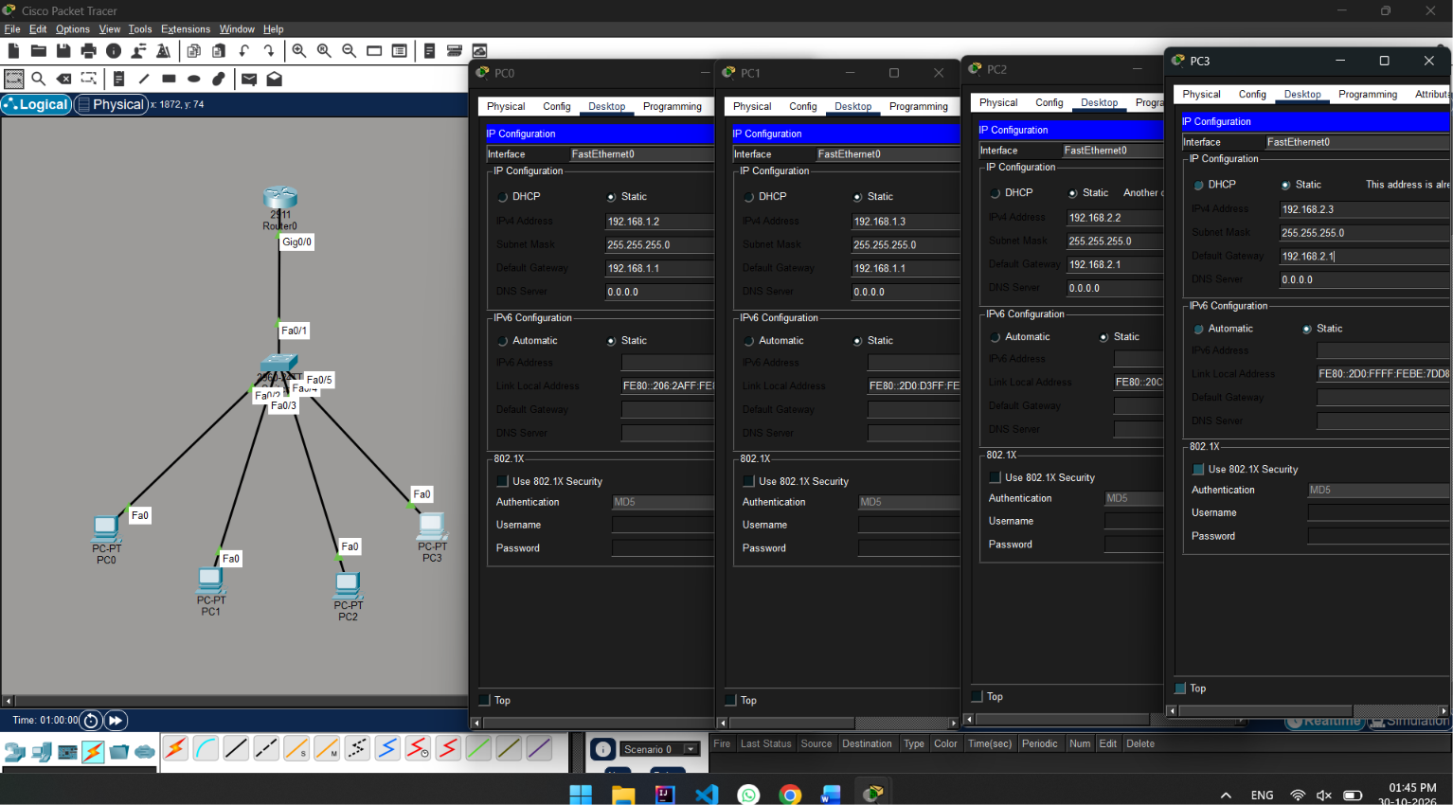

Step 7: show packet transer in packet tracer

1. Click Simulation Mode at the bottom-right.
2. Select Add PDU
3. Click PC0.
4. Click PC2.

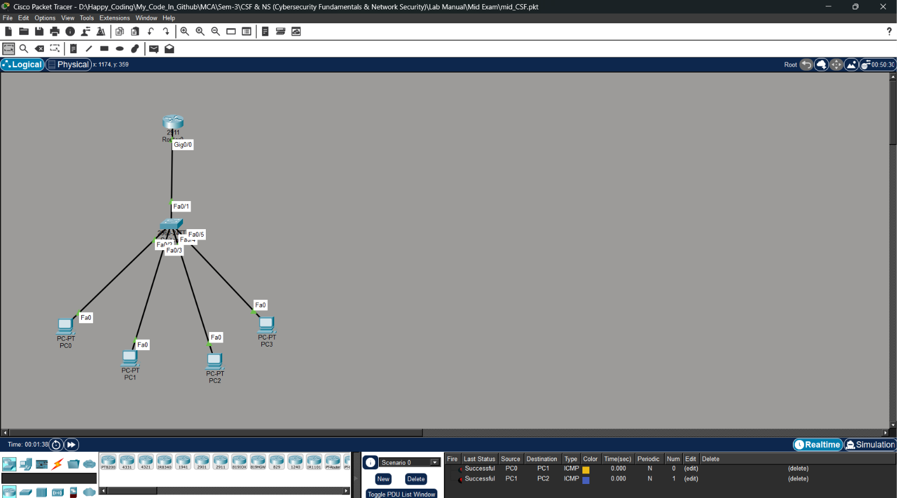

Practical: 02
AIM: A college is hosting a public website, but its current firewall rules allow broad traffic to the internal network. Using Draw.io or a neat, labelled diagram, redesign the network with an Internet connection, firewall, DMZ web server, IDS, and internal network. Write three suitable firewall rules following the least privilege principle.

Network Scheme
DMZ Network
Network / Device | IP Address
DMZ Network | 192.168.20.0/24
Web Server | 192.168.20.10
Internal LAN | 192.168.10.0/24
File Server | 192.168.10.20
DNS Server | 192.168.10.30
Workstations | 192.168.10.100 – 200
Firewall LAN | 192.168.10.1

Misconfigured Firewall Rules
Action | Protocol | Source IP | Destination IP | Port
DENY | HTTPS | Any | 192.168.20.0/24 | 443
ALLOW | FTP | Any | 192.168.10.30 | 22
ALLOW | IP | Any | Any | Any

Misconfigurations Rules:

- HTTPS rule: It denies HTTPS traffic to complete DMZ network instead of allowing it only to the required web server.

- FTP rule: It allows FTP traffic to an internal server and uses port 22, which is not the normal FTP port.

- ALLOW IP Any Any Any: This allows unrestricted traffic and is unsafe.

Corrected Firewall Rules
Action | Protocol | Source IP | Destination IP | Port
ALLOW | HTTPS | Any | 192.168.20.10 | 443
DENY | FTP | Any | 192.168.10.0/24 | 21
DENY | IP | Any | Any | Any

Network Topology
The external network represents the untrusted Internet. Incoming traffic first passes through IDS, that monitors traffic for suspicious activity.

DMZ: contains the public Web Server 192.168.20.10.
Internal LAN: contains the DNS server, File Server and user workstations.

The Web Server is keep in the DMZ so that a compromise of public-facing server does not directly expose the internal network. This DMZ concept is common to both source practicals.

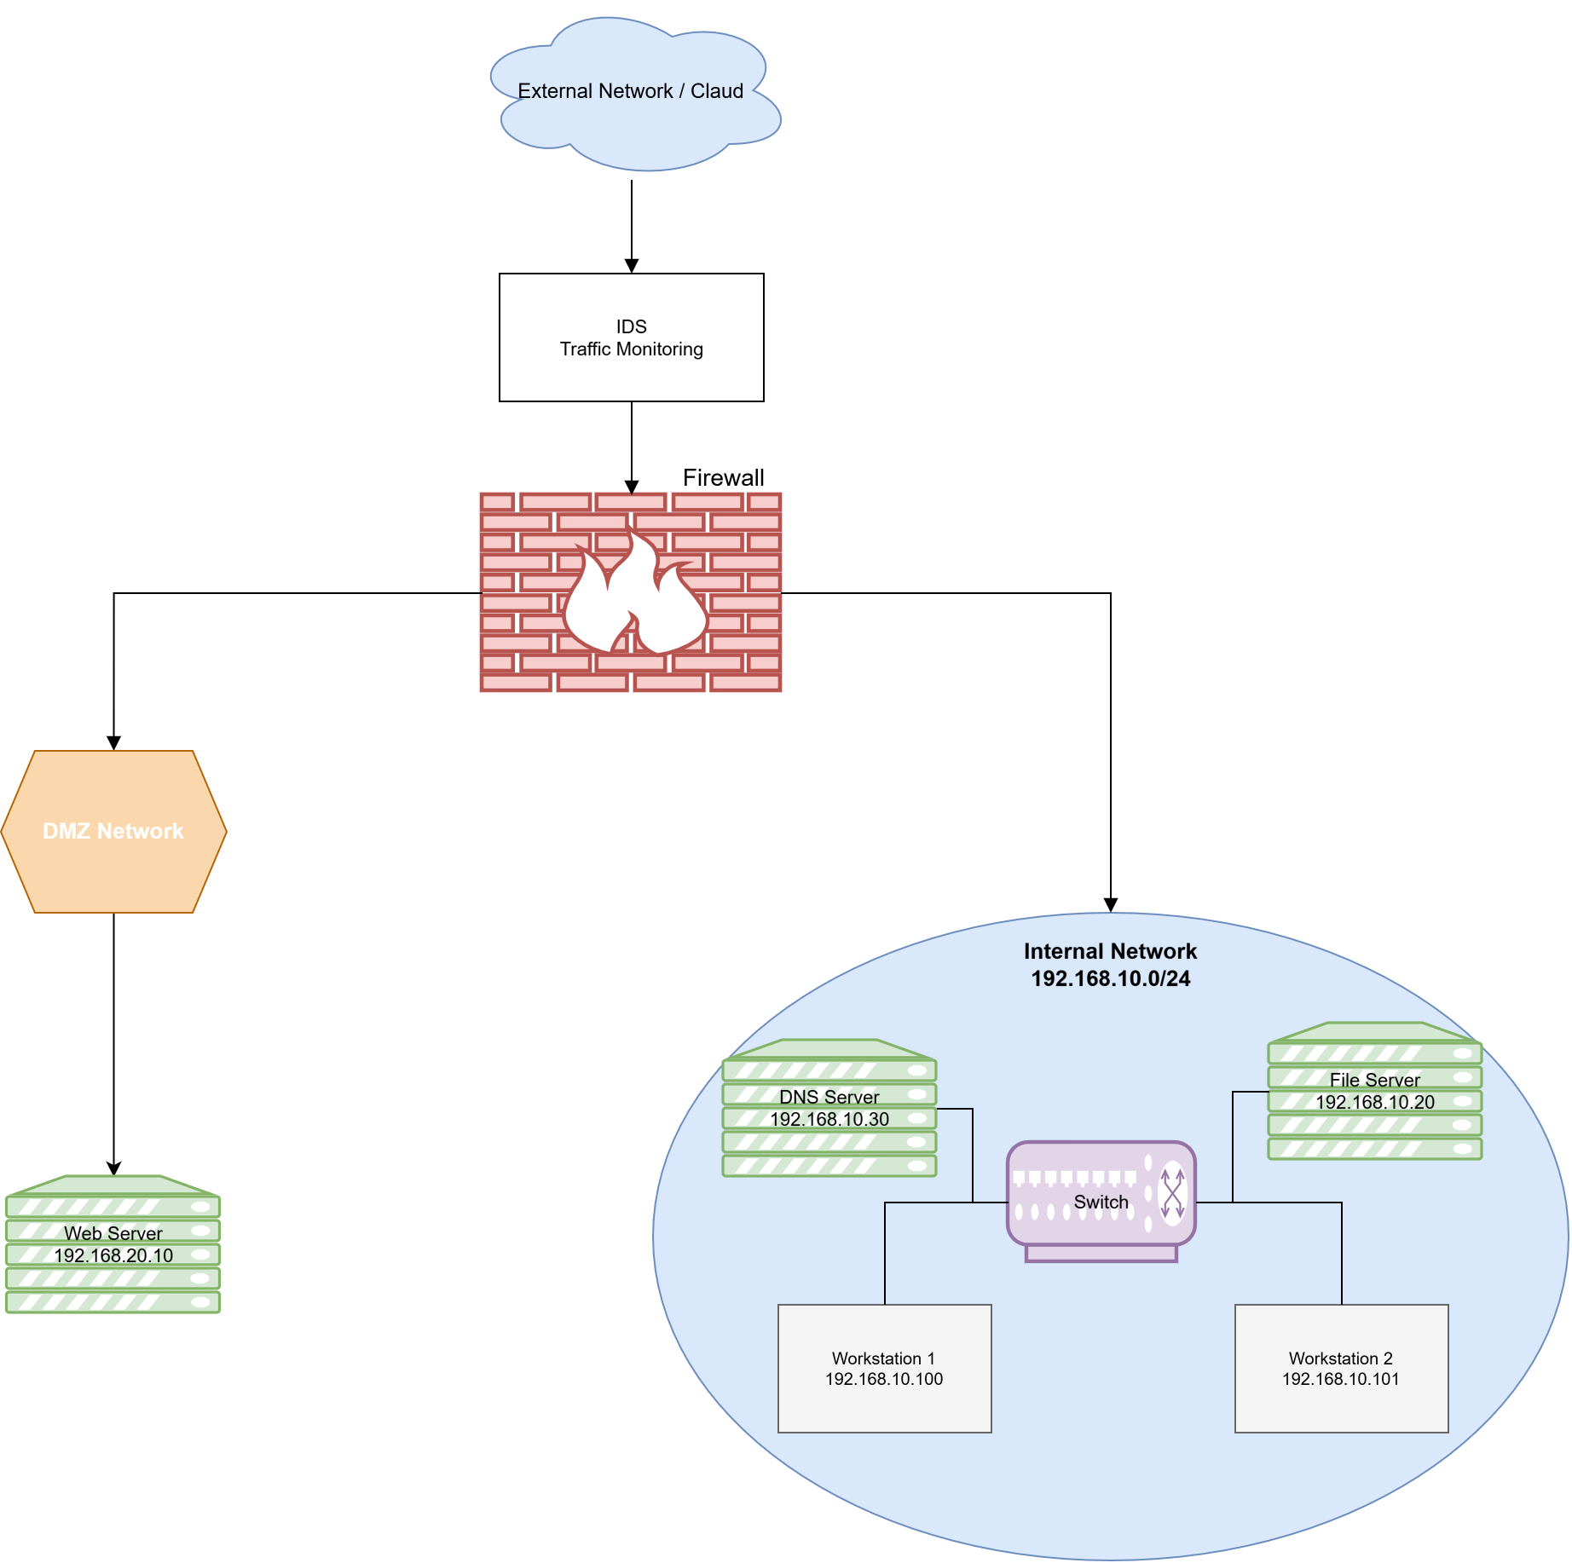
Figure 5: Secure Network Topology using DMZ, Firewall and IDS
POC Explanation
The topology shows traffic flowing from the External Network then IDS then Firewall and then DMZ/Internal Network.
IDS monitors incoming traffic for suspicious activity.
firewall controls and filters network traffic.
DMZ contains public Web Server and internal LAN contains trusted servers and workstations.
This separation helps protect internal resources from external threats.

Conclusion

Here firewall rules were analyzed and misconfigurations is identified. Three rules were corrected by restricting HTTPS to the DMZ web server, blocking FTP access to the internal network, and denying unspecified traffic. A secure network topology was also designed using a DMZ, firewall and IDS. The web server was placed in the DMZ so that it can provide public services without being directly connected to the internal LAN. The IDS was placed near the network perimeter to monitor suspicious traffic.

Observation Questions:

- Why is a trunk link required between the switch and router in a router-on-a-stick setup?
- The link between Switch0 Fa0/1 and Router0 G0/0 is configured as a trunk link. It carries traffic from both VLAN 10 and VLAN 20 through one physical connection. The trunk uses 802.1Q encapsulation to identify the VLAN traffic. This allows the router to handle communication between the two VLANs.

- Why is an unrestricted ‘allow any to any’ firewall rule dangerous?
- Port 443 provides encrypted HTTPS communication, but allowing traffic from ANY source to ANY destination is overly permissive. If an exposed service is vulnerable, attackers may still reach it through port 443. The source and destination should be restricted to only what is required.

*** END OF ANSWERSHEET ***

